TNE20003 – Internet and Cybersecurity for Engineering Applications

Portfolio Task – Lab 5 Credit Task

Aims:
- To observe and investigate the functionality of the TCP and UDP protocols at the transport layer.
- Observe NAT at work and understand the translation process

Preparation:
- View “Transport Layer Services” & “NAT & DHCP”

Due Date:
- Your Task will be assessed via an online quiz. You must score the required minimum to pass the test. You will be allowed a number of attempts to pass the test at the grade level you attempt. You are encouraged to complete the test at the end of the lab but if you do not, you must complete it before your next lab class.

Task 1.
Build the network provided in figure 1 with Cisco Packet Tracer
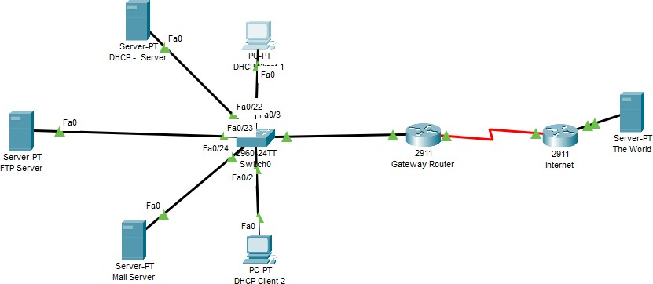

Figure 1

Use the network you built and tested in the Pass task for lab 5 to answer the following questions.

Task 2.
- Alter the DHCP pool of addresses to 2 instead of 100.

  - Add another DHCP Client 3 and describe what happens when this client tries to get an IP address.
After setting the max users to 2, the third client requests an IP but it is failed because pool is full.
  - Show this outcome on the simulation. What happens to the broadcast packets sent by the host seeking an IP address?
The packet only reach to DHCP server.

  - What are the src and dst port numbers used? Does it make sense?
The src port 68 and dst port 67. This make sense because DHCP communication in use UDP port 68 use for client and port 67 use for server.

  - What are the src and dst IP addresses?

The src IP :0.0.0.0 and dst ip is 255.255.255.255.

  - Which transport layer protocol is being used? Explain why.
The UDP transport layer protocol is used for DHCP because it provide an efficient IP address assignment in network.

  - If you alter the DHCP pool of addresses to 3 and carry the request from client 3 again what happens? Why?
The DHCP pool will fulfill the request from Client 3 because there are three IP addresses in the pool, and only two clients have been assigned IPs, so the remaining IP address will be assigned to Client 3, which requested it.
- Let’s investigate the FTP server a little bit more.
  - Log into the ftp server with username Dragan and password Fire as in the Pass task.
  - Analyse the packet when you type “dir” to see what files are available for copying. What are the src and dst ports used?
The src port 1030 and dst 21.
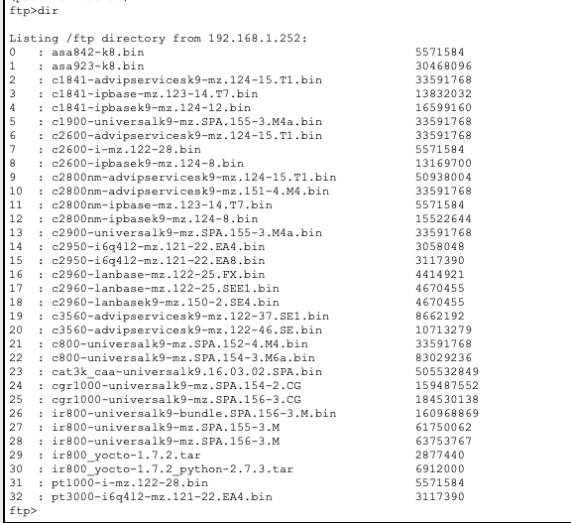
  - Which part of the ftp process does this output represent? See picture below:
This output represents the file which have been forward from client to server.

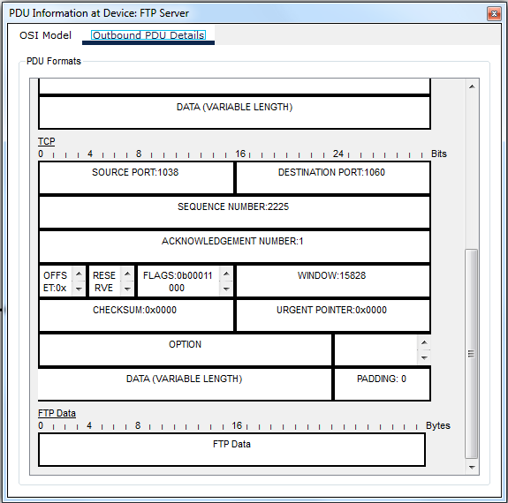
~~~~~ End of Lab ~~~~~

